PREPARATION PHASE WORKING WITH THE DATASET

|  |  |
| --- | --- |
| **Team ID** | PNT2022TMID38117 |
| **Project Name** | Retail store stock inventory analytics |

Understanding the dataset

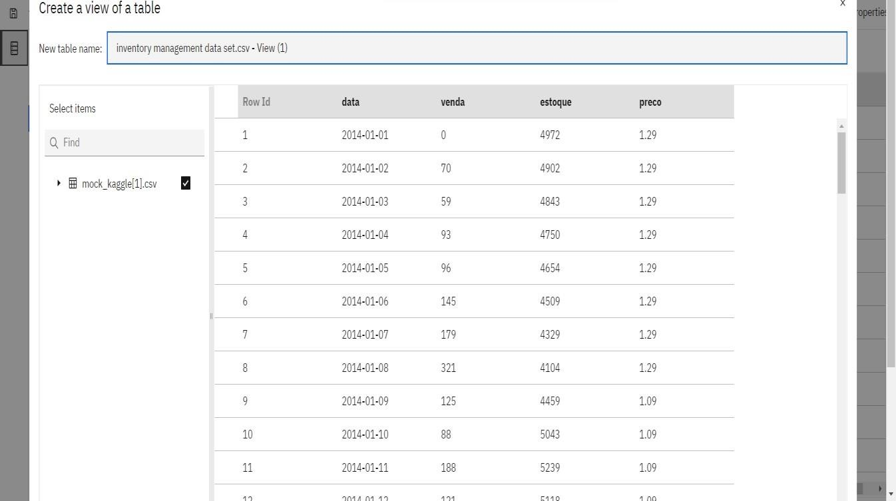



Loading the dataset

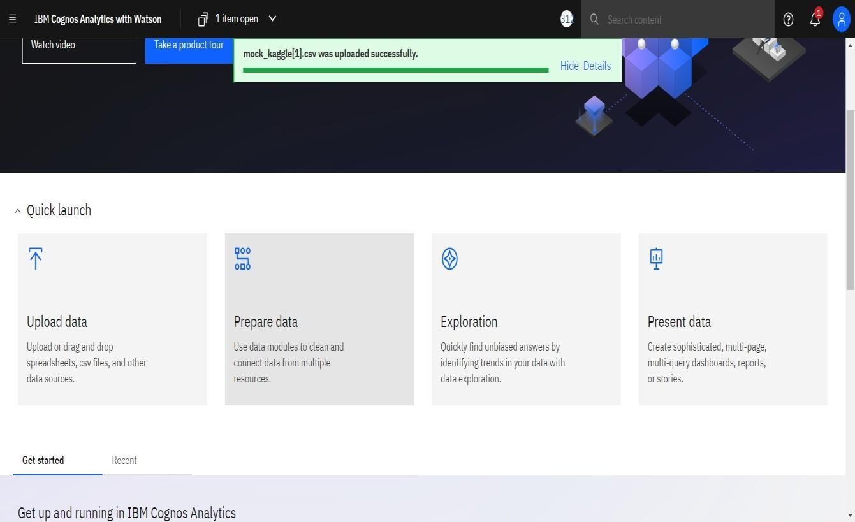

Prepare the dataset

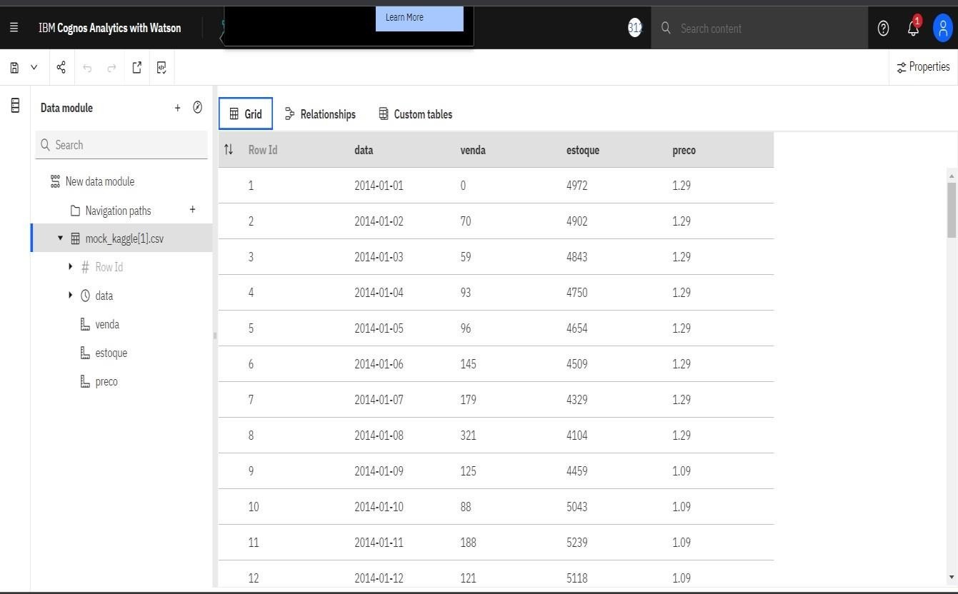

REFERENCE LINK

https://us1.ca.analytics.ibm.com/bi/?perspective=ca- modeller&pathRef=.my_folders%2Finventory%2Bmanagem net